Name: **MyTunesGUI**

Description: **Chapter 12 – Programming Exercise 4**

**Select and purchase songs from a list box**

Write a C# GUI application that contains a ListBox with the titles of eight songs available for purchase. Provide directions that tell the user they can choose as many songs as they want by holding down the Ctrl key while clicking on the desired selections. As the user makes selections, display the number of songs selected and the total cost for the selected movie(s). If the user deselects a song, update the number of songs and total cost accordingly. Deselect a song by using the Ctrl key and clicking on the selected song. If the user deselects all selected songs, clear the display label of its contents. Purchase price is $0.99 per song. Design your GUI as shown.

Song Title and Artist

Thriller - Michael Jackson

Rocket Man - Elton John

Atomic Dog - George Clinton

Highway to Hell - ACDC

Bad Company - Bad Company

Born in the USA - Bruce Springsteen

God Blessed Texas - Diamond Rio

Beast of Burden - Rolling Stones

Create a Click event method for the songsListBox. Within the method, declare any constants and variables needed. Count the number of songs selected from the ListBox using (SelectedItems.Count). Use an if-else statement to determine if one song was selected. If only one song was selected, calculate the cost and display the appropriate cost information message. If more than one song was selected, calculate the cost and display the appropriate cost information message. Items in the display label are to appear as shown. Use an if statement to determine if count equals zero – if it does, clear the contents of the cost label. When finished coding this Click event, go back to the Design window and use the *Events* list in the Properties window and apply a SelectedIndexChanged event to the ListBox.

Complete the Pseudocode Template document for this programming request. A printed version is due upon arrival to class on lab day.

Use your completed Pseudocode document to create the C# application. Create and save the application to your classroom USB flash drive.

*\*\*\* Sample Program Output on Next Page \*\*\**

GUI When Started Sample Program Output (1)

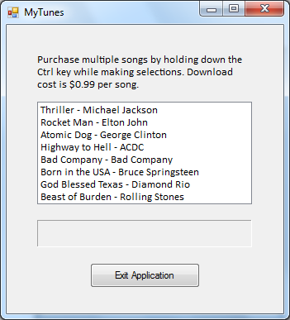 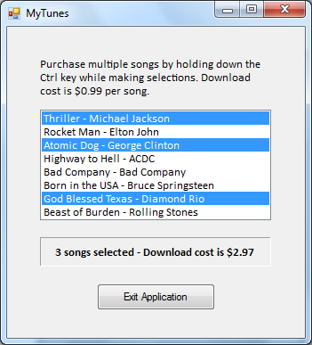

Sample Program Output (2) Sample Program Output (3)

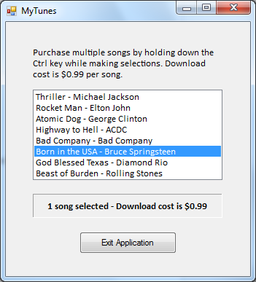 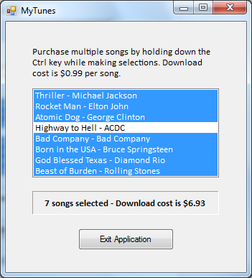

*\*\*\* Sample Program Output on Next Page \*\*\**

Sample Program Output (4) – All Songs Deselected from Sample Program Output (3)

